

DAEDO PSS TEST MATCH DAY

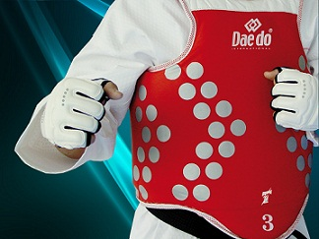

CARRONSHORE COMMUNITY CENTRE
Falkirk, FK2 8EX

SATURDAY 25TH APRIL
10am to 2pm

Special Guest:
International Referee – James Lewsley

All Matches - 3 x 1 min 30 sec

Players will be supplied with E-Headgear and E-Body Protector
All other protective gear is the responsibility of the player including E Foot Protectors

Matches will be decided on the day

Players Fee - £5.00

