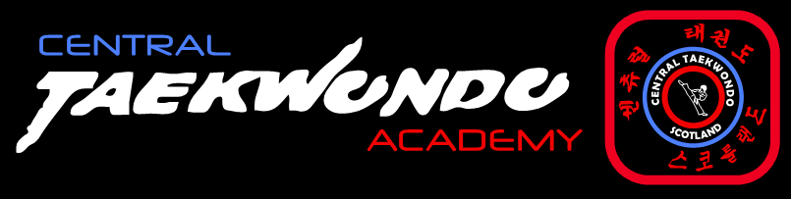

SUMMER CAMP

CAMP 1 – WED 5TH AUGUST
CAMP 2 – FRI 7TH AUGUST
***** CAMP 3 – TUE 11TH AUG *****
CAMP 4 – WED 12TH AUG
TIMES - 10.00am to 1.00pm

Open to all ages and grades

CARRONSHORE COMMUNITY CENTRE

CLASSES WILL INCLUDE:
FITNESS & FUN

CIRCUIT TRAINING
PAD WORK
COMPETITIONS & PRIZES

EXTRA PREPARATION FOR COLOURED BELT GRADINGS

ONLY £15 PER DAY

Or 2 DAYS - £25.00/3 DAYS - £40.00/4 DAYS - £50.00

Price includes a healthy snack of fruit, veg & water
(No dobok required – t-shirts and joggers)

To book a place email info@central-taekwondo.com or phone Angie on 557004

Deadline for bookings
Monday 3rd August

Full payment required on booking Limited spaces so please book early
****AMENDED DATE****

