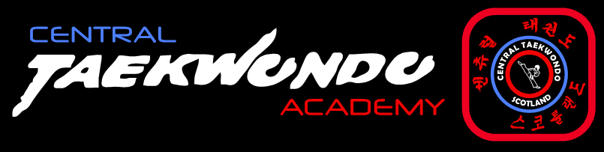

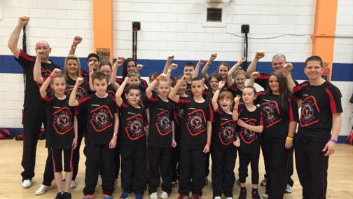
SPORT TKD
DEVELOPMENT TRAINING WEEKEND
WITH COACH STUART & COACH DARREN
SATURDAY 6TH & SUNDAY 7TH JUNE 2015
OPEN TO YELLOW BELTS & ABOVE
£15 FOR 1 DAY OR £20 FOR BOTH
10am – 4pm
NAMES TO ANGIE/SHONA/STUART
ALL MONEY TO CLUB FUNDS

